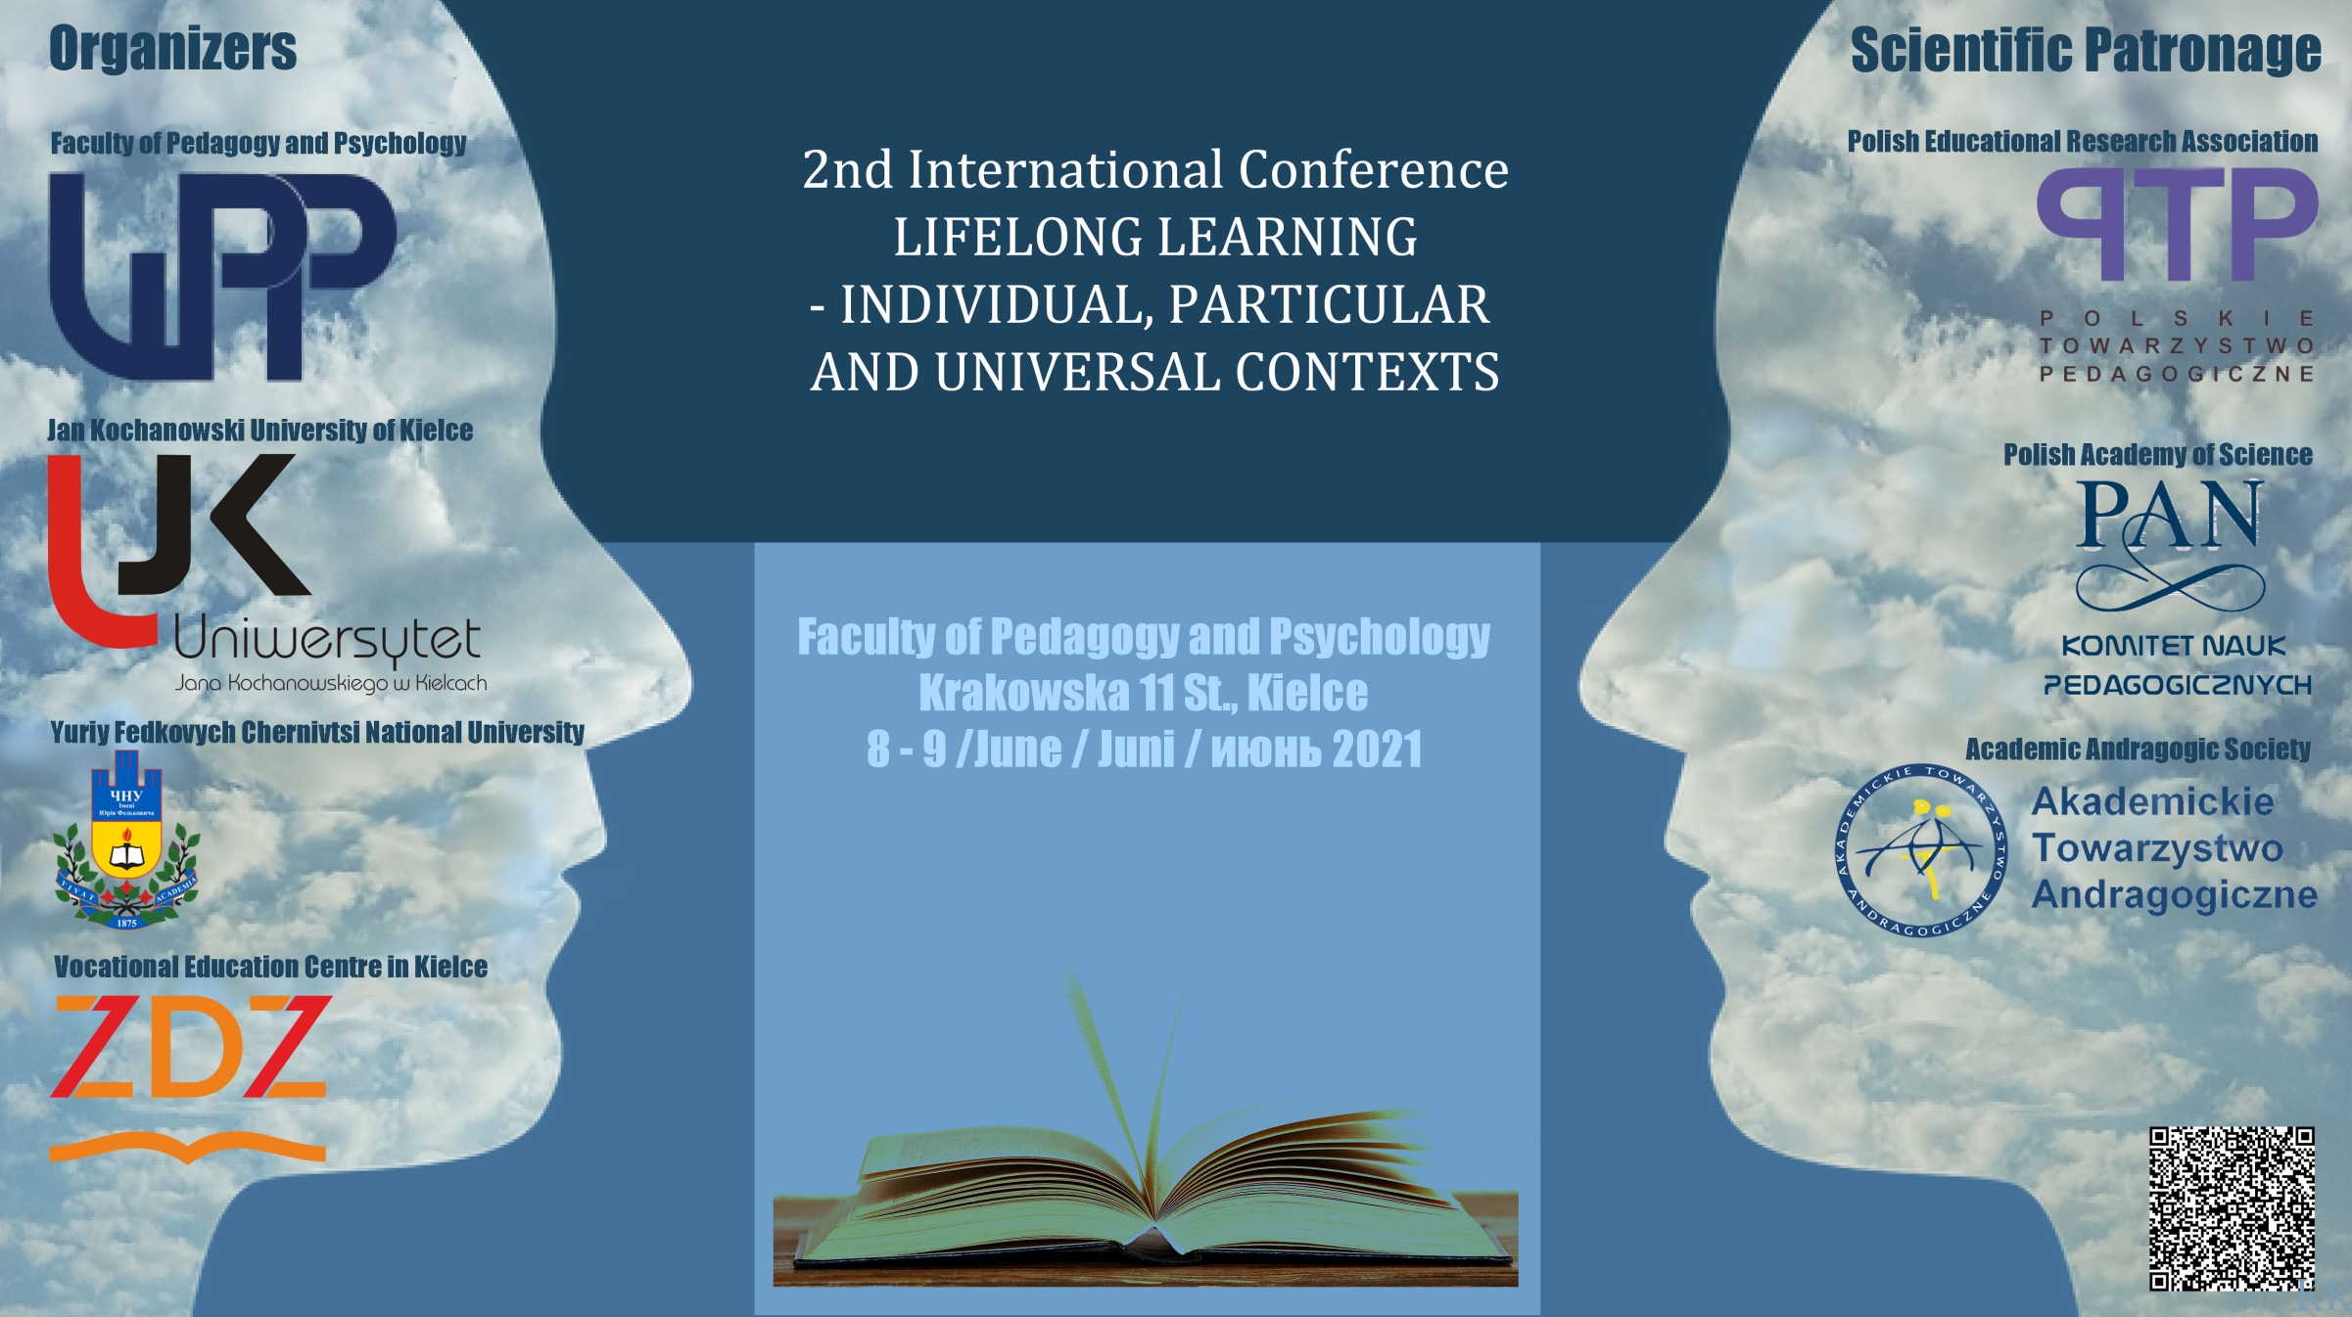

Conference Call -2

The epidemic situation in our country is not conducive to face-to-face meetings. Although we all yearn to meet, talk, present our research and exchange our experiences, fear for our own health makes us prefer to limit meetings to the necessary minimum.
In the first call, we offered an opportunity to choose the preferred form of participation. We were optimistic to think we would be able to organize a hybrid conference. However, there are only 3 registrations for the on-site meeting, and the majority the participants chose the on-line conference. Therefore, the Organizing Committee decided to hold a fully on-line conference.
All the necessary information concerning the participation will be sent after 20th May 2021.

Publication:
We would like to inform that the papers to publish should be prepared till 15th June 2021 and sent to edukacjaustawicznaujk@gmail.com
The papers should be prepared in accordance with the requirements of the editors:

* „Humanitas University's Research Papers- Pedagogy”:
- https://humanitas-pedagogika.publisherspanel.com/resources/html/cms/DEPOSITSMANUSCRIPT

** „Journal of Continuing Education”- https://edukacjaustawicznadoroslych.eu/index.php/pl/dla-autorow

*** The authors interested in publishing the chapter in a peer-reviewed collective work published in Adam Marszałek Publishing House (https://marszalek.com.pl/en/about) are kindly asked to contact the Organising Committee (edukacjaustawicznaujk@gmail.com)

Registration:
- Conference fee must be paid to the following account:
FUNDACJA RESTART
Milczany 123, 27-600 Sandomierz
71 1050 1416 1000 0090 3157 9676

- Please, in the title - give the NAME & SURNAME and the term „EDUKACJA”

Thank you for your registration. See you at the conference.

The Organising Committee

